## CS3335 Assignment 2 Due: 08/31/17

1. (15 points) Complete the attached program plot.c to plot a function f(t), e.g. f(t)=t^2-4t+5 for values of t between two values as specified as two variables low and high on line 11 in plot.c. Note, first, nested loops are NOT allowed in your program; second, I am going to change the definition of f(t) when testing your program; third, I am going to change the values of low and high when testing your program.

Please find a few example f(t)shown as comments in the bottom of plot.c. The following are their corresponding outputs.

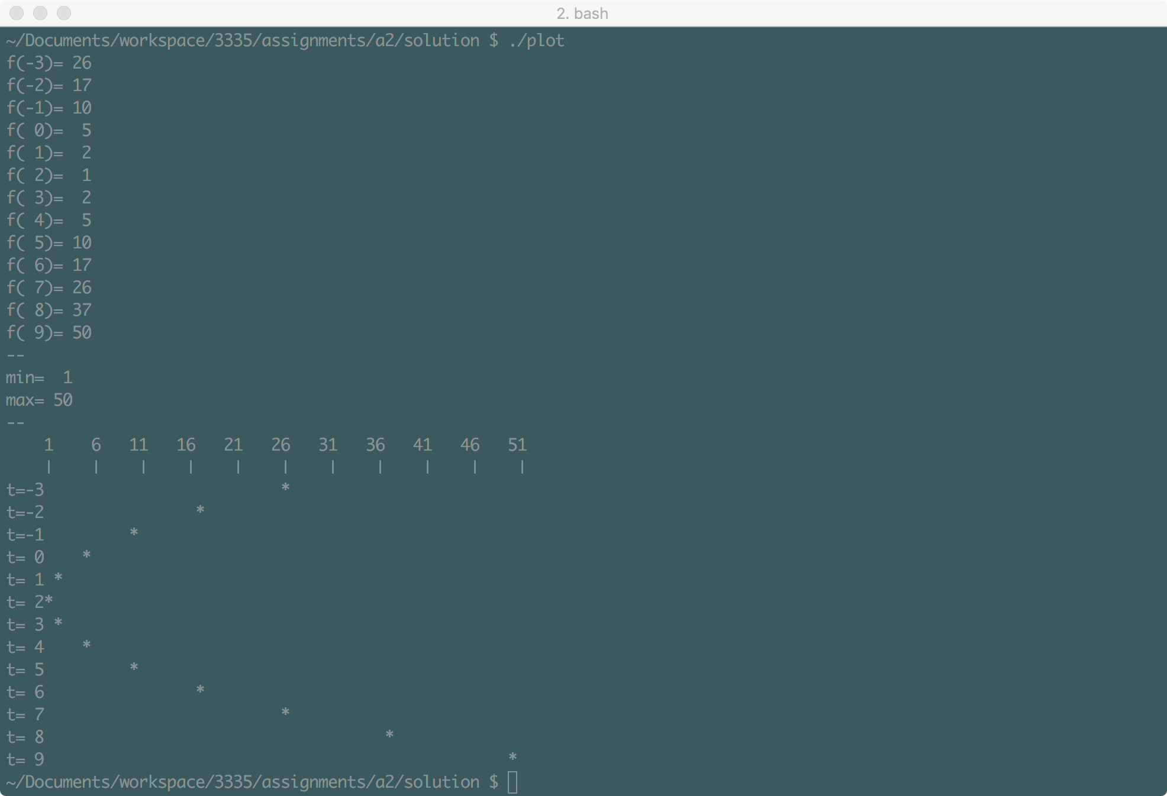

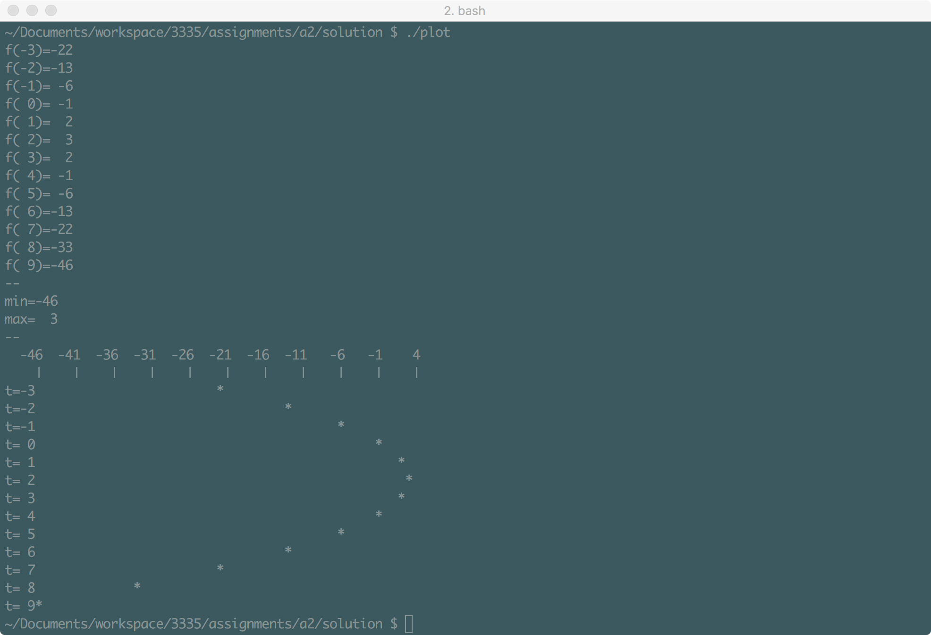

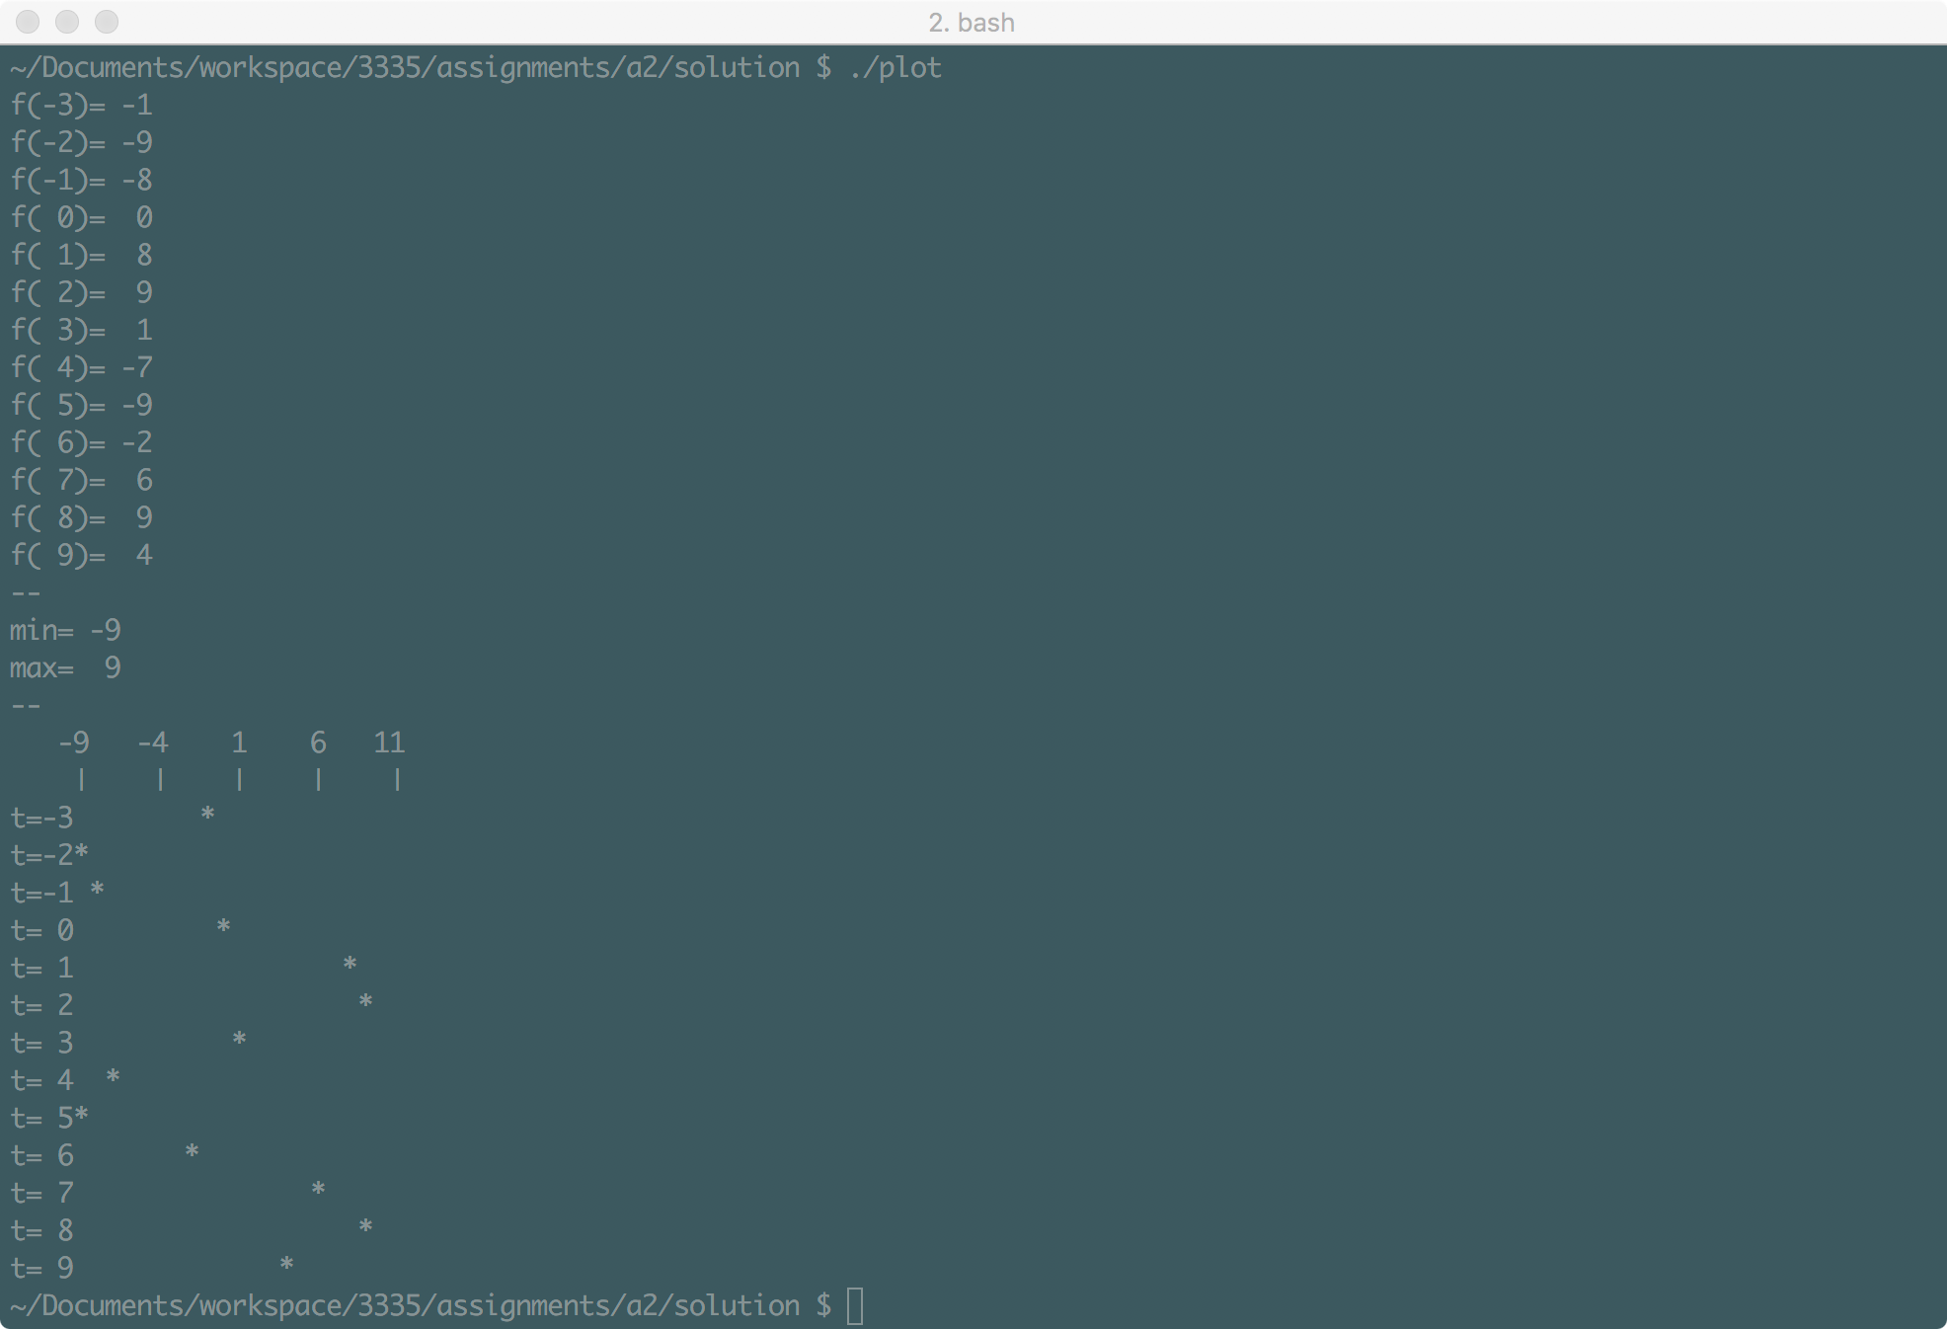

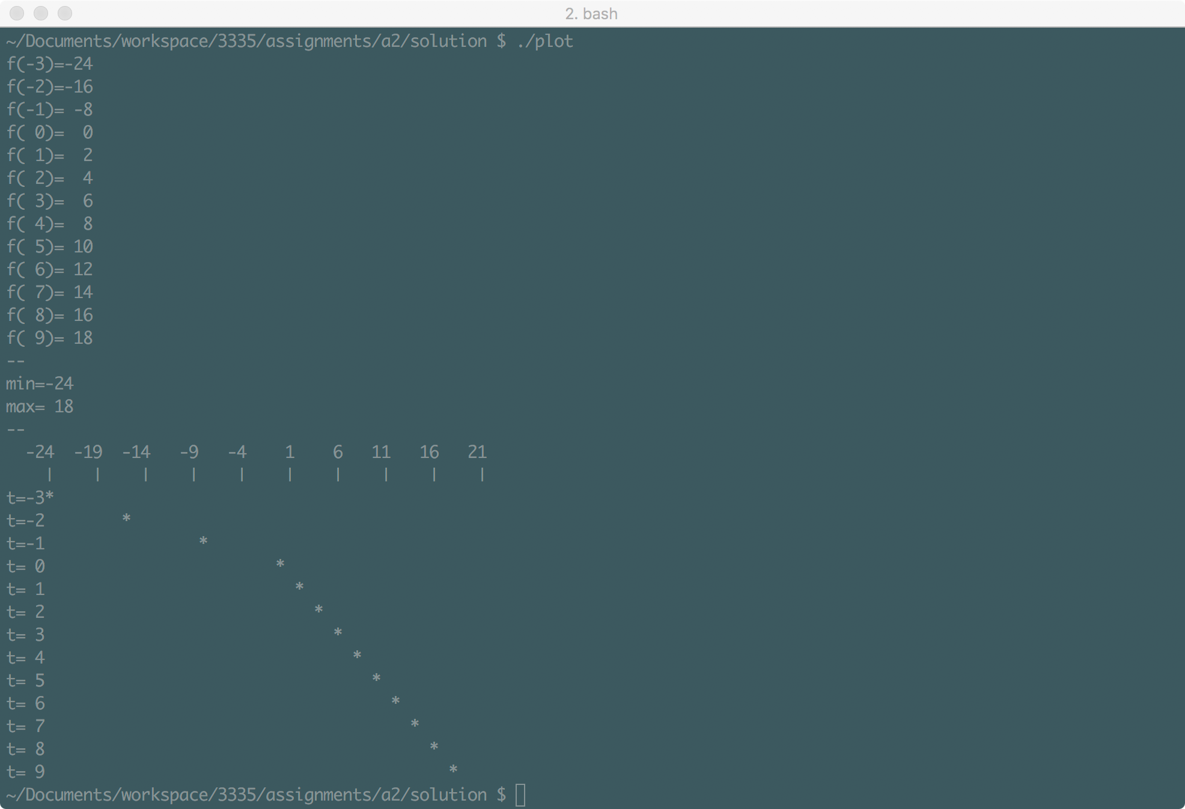

Hint:

First, for all t between low and high, find the minimum f(t) and maximum f(t), let’s call them f_min and f_max respectively.

Then create an array of characters (i.e. a string) whose size is f_max-f_min+2. This is of course taking advantage of the fact that in C, when defining an array, its size is allowed to be a variable. For instance:

int m=3*6;

char ex[m];

Then for each value of t, in the string you created above, store an asterisk in the element whose index is corresponding to the function value f(t-f_min), while all leading elements before the asterisk (if any) are blank and the element at f(t-f_min+1)is a ‘\0‘. This is of course assuming that the f(t-f_min)value is rounded to an integer. Print the string out, clear it up, and go on to the next value of t.

1. (10 points) Change the bitmasks.c program by **adding the following two functions** and change the main function accordingly to test them.

unsigned setbits (unsigned x, int p, int n, unsigned y) that returns x with the n bits that begin at position p (right-adjusted) set to the rightmost n bits of y, leaving the other bits unchanged. Note: **it does not change the values of x and y though**.

For instance, if x is equal to 2004384122

|  |  |  |  |
| --- | --- | --- | --- |
| 0111 0111 | 011**1** **100**0 | 0111 1001 | 0111 1010 |

and y is equal to 1634952294

|  |  |  |  |
| --- | --- | --- | --- |
| 0110 0001 | 0111 0011 | 0110 0100 | 0110**0110** |

Then setbits (x, 20, 4, y) returns

|  |  |  |  |
| --- | --- | --- | --- |
| 0111 0111 | 011**0 110**0 | 0111 1001 | 0111 1010 |

unsigned invertbits (unsigned x, int p, int n) that returns x with the n bits that begin at position p (right-adjusted) inverted, i.e. 1 changed to 0 and vice versa, leaving the other bits unchanged. Note: **it does not change the value of x though**.

For instance, if x is equal to 2004384122

|  |  |  |  |
| --- | --- | --- | --- |
| 0111 0111 | 0111 **1000** | **0111** **1**001 | 0111 1010 |

Then invertbits (x, 19, 9) returns

|  |  |  |  |
| --- | --- | --- | --- |
| 0111 0111 | 0111 **0111** | **1000** **0**001 | 0111 1010 |

**What to turn in?**

Create a tarball file by the name of cs3335_a2_yourlastname.tar that includes

* Completed source code file plot.c for question 1.
* Completed source code file bitmasks.c for question 2.

Submit the tarball file through BlazeVIEW by the due time.